**HOW TO CREATE RUNNABLE JAR**

1. Create MANIFEST.MF file inside SRC.

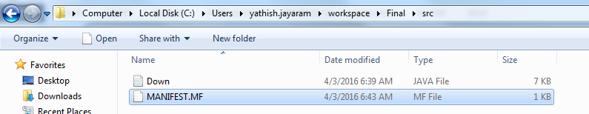

1. Compile the .java file to create .class file along with java-json.jar.

(Here I am adding JSON.jar while compiling to cover Bonus work)



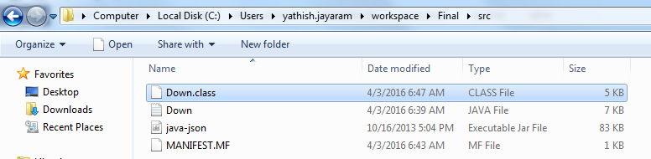

1. Write the below text inside the MANIFEST.MF file.

Manifest-version: 1.0

Class-Path: java-json.jar

Main-Class: Down

Note: - Down is the class name it will vary according to Program. And Press enter after completion on Main-Class: Down line so the cursor goes to fourth line.

1. Command to Create Jar file

Jar cfm jarname.jar manifest.mf classname.class

* The c option indicates that you want to *create* a JAR file.
* The m option indicates that you want to merge information from an existing file into the manifest file of the JAR file you're creating.
* The f option indicates that you want the output to go to a *file* (the JAR file you're creating) rather than to standard output.

1. Run the command below to create Jar.



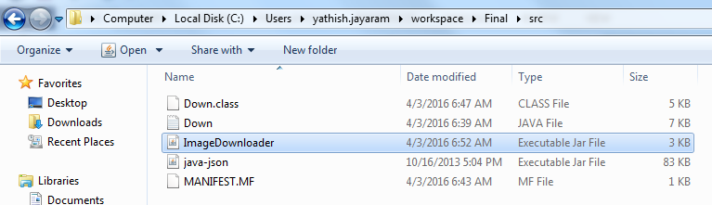

1. Later to execute jar.



1. The output images and Image Details will be saved where ever you are keeping the jar file along with java-json.jar.

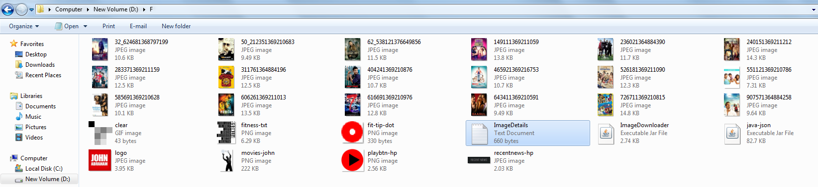

JSON jar can be Downloaded through the below link

<http://www.java2s.com/Code/Jar/j/Downloadjavajsonjar.htm>

***END***

Wrong approach will learning to create jar file.

Jar –cvf ImageDownloader.jar Down.class



The above command will also create jar file but the no main manifest attribute error.

So it shows the below error if we run the jar.

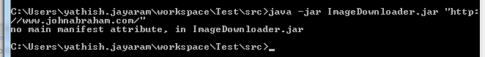

Because we are not adding in the library and running only in Command line.